**Table of Contents**

|  |  |
| --- | --- |
| **1. Introduction** | 4 |
| * Overview of the SCS System | 4 |
| * Purpose of this Manual | 4 |
| * Getting Started | 5 |
| * System Setup | 5 |
| * System Overview | 6 |
| * User Role Authentication | 6 |
| **2. System Navigation** | 7 |
| * Dashboard Overview | 7 |
| * Key Performance Indicators (KPIs) | 8 |
| * Sales and Expense Targets | 8 |
| * Graphical Data Representation | 9 |
| * Navigation and Button Functions | 9 |
| **3. Admin Module** | 10 |
| * Managing Admin Functions | 10 |
| * User Profile Management | 11 |
| * Registering Accounts | 11 |
| * Managing Inventory & Payroll Access | 12 |
| **4. Inventory Module** | 13 |
| * Introduction | 13 |
| * System Navigation | 14 |
| * Product/Service Management | 15 |
| * Sales Listing | 16 |
| * Purchase Listing | 17 |
| * Project Listing | 18 |
| * Sales Report | 19 |
| * Purchase Report | 20 |
| * Target Goals | 21 |
| * Settings | 22 |
| **5. Key Features and Their Functions** | 23 |
| * Bill Type Management | 23 |
| * Branch Management | 24 |
| * Cash Bank Management | 25 |
| * Customer Management | 26 |
| * Invoice Type Management | 27 |
| * Product Type Management | 28 |
| * Product Management | 29 |
| * Purchase Orders | 30 |
| * Sales Orders | 31 |
| * Shipment Type Management | 32 |
| * Unit of Measurement (UOM) | 33 |
| * Vendor Management | 34 |
| * Warehouse Management | 35 |
| **6. Payroll Module** | 36 |
| * Allowance Management | 36 |
| * Attendance Management | 37 |
| * Employee Benefits Management | 38 |
| * Employee Contribution Management | 39 |
| * Salary Deduction Management | 40 |
| * Department Management | 41 |
| * Employee Management | 42 |
| * Job Position Management | 43 |
| * Leave Management | 44 |
| * Project Management | 45 |
| * Shift Management | 46 |
| * Tax Management | 47 |
| * Payroll Generation and Payslip Processing | 48 |

1. **Introduction**

The SCS System is designed to help businesses manage their products, sales, purchases, and employee payroll in an organized manner. This document provides an easy-to-understand overview of how the system works without requiring programming knowledge.

1. **Purpose of this Manual**

The primary purpose of this manual is to empower users like you to maximize the benefits of our system. By following the instructions and guidelines provided herein, you'll be equipped to navigate the system with confidence, troubleshoot common issues, and leverage advanced features to enhance your productivity. Whether you're a beginner or an advanced user, this manual will serve as your comprehensive resource for harnessing the full potential of our system.

1. **Getting Started**

Before diving into the functionalities of SCS System, it's essential to familiarize yourself with the basics. This section will guide you through the initial setup process and provide an overview of the system's interface and navigation.

**1. System Setup**

To get started with SCS System, follow these steps:

* **Installation:** [Download the installer](https://mega.nz/file/uJZ23aCS#zTbMZkT85HNOdmX8dAtGxNEW0QZu7i4lED4n7-waPyQ) and follow the on-screen instructions to install the software.
* **Login:**

Before accessing the system, users must log in with their credentials. The login screen includes:

* **Username Field:** Enter your registered username.
* **Password Field:** Enter your secure password.
* **Login Button:** Click to authenticate and access the system.
* **User Role Authentication:** Determines user access levels (Administrator, Inventory, Payroll) and restricts access to specific modules accordingly.

Upon successful login, users will be directed to the system dashboard based on their role and permissions.

* **Configuration:** The system is already pre-configured and requires no additional setup.

1. **System Overview**

The system consists of three main sections:

* **Admin Management** – Allows administrators to manage user accounts and system settings.
* **Inventory Management** – Helps businesses keep track of products, sales, purchases, and vendors.
* **Payroll Management** – Manages employee salaries, attendance, benefits, and job roles.

1. **Button Functions Overview**

The system features various buttons with specific functions for navigation and operation:

* **Back Button (A black arrow pointing to the left

  AI-generated content may be incorrect.)** – Returns to the previous screen.
* **Add New Record (A black and white icon with text

  AI-generated content may be incorrect.)** – Opens a form to create a new entry.
* **Edit Record (A black pencil and text

  AI-generated content may be incorrect.)** – Enables editing of existing records. (Note: To edit an entry, click the record on the list then this button)
* **Save Record (A black and white symbol

  AI-generated content may be incorrect.)** – Saves changes made to a record.
* **Delete Record (A black and white symbol

  AI-generated content may be incorrect.)** – Removes the selected record from the system. (Note: To delete an entry, click the record on the list then this button)
* **Print (A black and white printer

  AI-generated content may be incorrect.)** – Generates a printable version of the document.

1. **System Features**
2. **Admin Module**

This module provides system administrators with access to user management and system settings.

**Managing Admin Functions**

1. **User Profile Management:** Navigate to the **Profile** section, where administrators can update their information, change passwords, and manage authentication settings.
2. **Registering Accounts:** Open the **Register Account** section, fill in user details, assign roles (Admin, Manager, Employee), and activate accounts.
3. **Managing Inventory & Payroll Access:** The **Inventory** and **Payroll** tabs allow the admin to control access permissions, ensuring only authorized personnel can manage these modules.
4. **Inventory Module**

* **Introduction**

This Inventory Management System helps users manage inventory records efficiently, including product listings, purchase reports, and sales data.

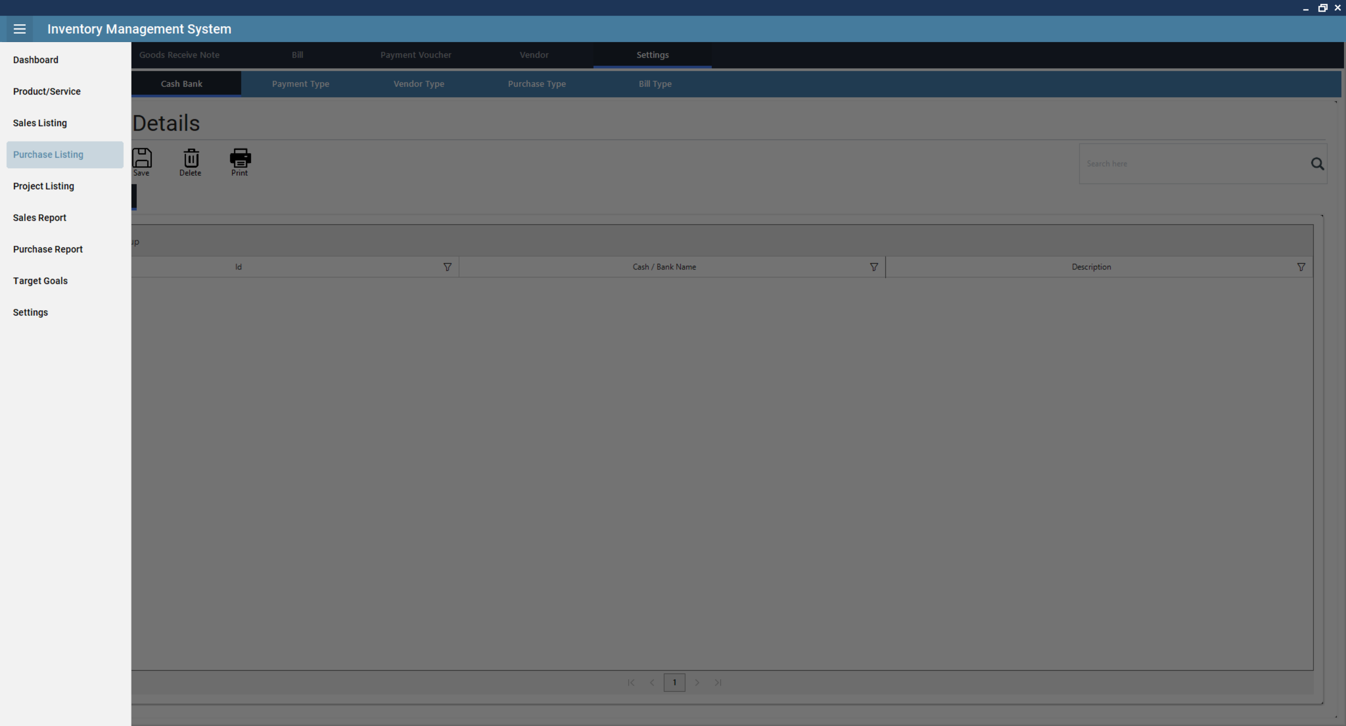

* **System Navigation**
* The system includes a sidebar menu and a top navigation bar.

1. *Sidebar Menu Options*

* **Dashboard**: The central hub of the Inventory Management System, providing a quick overview of key performance indicators, sales trends, and inventory status.

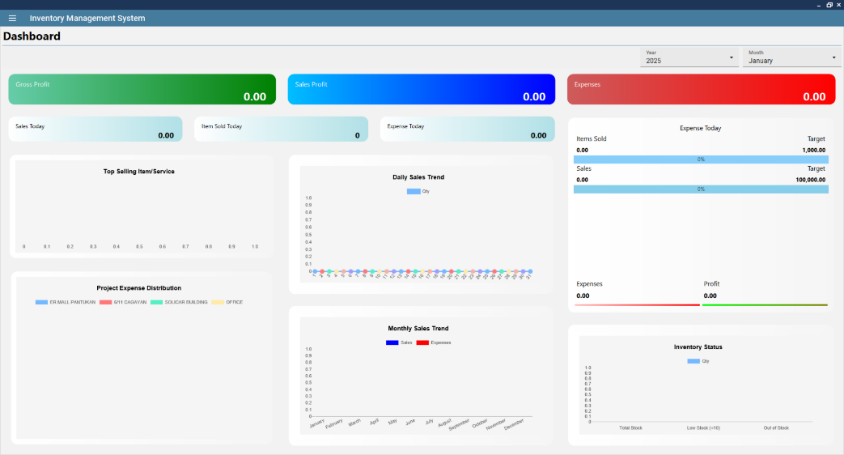

Below is a detailed guide on how to navigate and use the dashboard effectively.

* *Overview of Dashboard Components*

The dashboard consists of various widgets that display real-time data related to sales, expenses, and inventory.

* 1. **Key Performance Indicators (KPIs)**

At the top of the dashboard, three primary financial metrics are displayed:

* **Gross Profit (Green Box)** – Total profit from sales after deducting costs.
* **Sales Profit (Blue Box)** – Net profit earned from all sales.
* **Expenses (Red Box)** – Total expenses incurred within the selected time frame.

Additionally, the following statistics are shown:

* **Sales Today** – Total sales made on the current day.
* **Items Sold Today** – Number of items sold today.
* **Expense Today** – Expenses recorded for the current day.
  1. **Sales and Expense Targets**
* **Items Sold vs. Target** – Displays progress towards the sales goal.
* **Sales vs. Target** – A comparison of actual sales revenue against the sales target.
* **Expenses vs. Profit** – Shows total expenses versus profit margins.
  1. **Graphical Data Representation**

The dashboard features multiple charts and graphs:

* **Top Selling Item/Service** – Displays the best-selling products or services.
* **Daily Sales Trend** – Line graph indicating daily sales patterns.
* **Project Expense Distribution** – Breakdown of expenses across different projects.
* **Monthly Sales Trend** – Sales vs. expenses comparison over the months.
* **Inventory Status** – A bar chart showing:
  + Total stock available
  + Items with low stock (<10 units)
  + Out-of-stock items
* *How to Use the Dashboard*
  1. Selecting Date Ranges
     + - The Year and Month selection dropdowns in the top-right allow users to filter data based on specific timeframes.
  2. **Monitoring Key Metrics**
     + - The color-coded KPI boxes give a quick financial summary.

The progress bars in the Sales and Expense section indicate how close the company is to its targets.

* 1. **Analyzing Trends**
     + - The Daily Sales Trend helps users track fluctuations in sales.
       - The Monthly Sales Trend compares expenses and revenue over time.
       - The Inventory Status chart warns users about low or out-of-stock items.
* **Product/Service**: This module enables users to efficiently manage inventory items, including adding, editing, deleting, and printing product details. Additional functionalities include **stock-in logging, stock monitoring, product type management, and unit of measure management**. For details on product types and units of measure, please refer to the **Key Features and Their Functions** section.
* **Sales Listing**: This module enables users to efficiently manage sales transactions, including adding, editing, deleting, and printing sales order details. Additional functionalities include **generating reports, issuing invoices, processing payments, warehouse management, customer management, and settings** which includes **sales type, customer type, shipment type, and invoice type** (please refer to the **Key Features and Their Functions** section).
* **Purchase Listing**: This module enables users to efficiently manage **purchase transactions**, including adding, editing, deleting, and printing purchase order details. Additional functionalities include **generating reports, processing bills and vouchers, managing goods receipt notes (GRN), vendor management, and settings**, which include **purchase type, vendor type, payment terms, and bill type** (please refer to the **Key Features and Their Functions** section).
* **Project Listing**: Manage inventory related to projects. Please refer to the **Key Features and Their Functions** section.
* **Sales Report**: This module provides a comprehensive overview of **sales performance**, including item sales, revenue, purchases, and net profit. Additional functionalities include **daily and monthly sales trends, breakdowns, and performance comparisons over different time periods**.

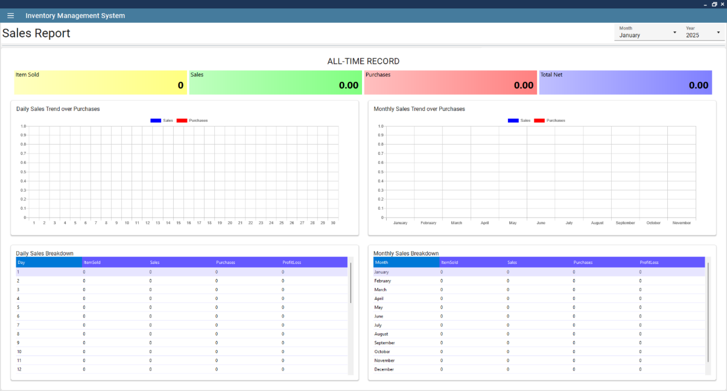

* *Overview of the Sales Report Page*

The **Sales Report Page** displays various key performance indicators and graphical representations to help users analyze sales trends. The main sections include:

* 1. **Key Sales Metrics (All-Time Record)**
     + **Item Sold (Yellow Box)** – Total number of items sold.
     + **Sales (Green Box)** – Total revenue from sales.
     + **Purchases (Red Box)** – Total expenditure on purchases.
     + **Total Net (Blue Box)** – Net profit after deducting purchases from sales.
  2. **Graphical Sales Trends**
     + **Daily Sales Trend over Purchases** – A graphical representation of daily sales (blue) compared to purchases (red).
     + **Monthly Sales Trend over Purchases** – A comparative graph of sales and purchases across different months.
  3. **Breakdown of Sales Performance**
     + **Daily Sales Breakdown Table**
       - Displays **day-wise sales performance** for the selected month.
       - Columns include: **Day, Items Sold, Sales, Purchases, and Profit/Loss**.
  4. **Monthly Sales Breakdown Table**
     + Summarizes **month-wise performance**.
     + Columns include: **Month, Items Sold, Sales, Purchases, and Profit/Loss**.
* **Purchase Report**: This module provides a comprehensive overview of **purchases**, including daily, monthly, and annual trends. It helps users track purchase transactions, analyze spending patterns, and optimize procurement decisions.

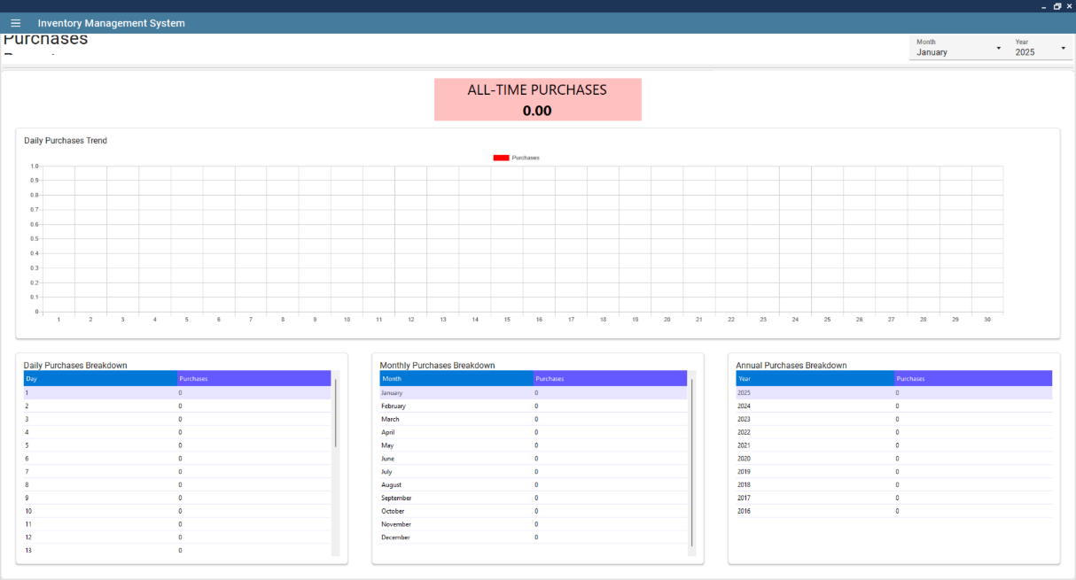

* *Overview of the Purchase Report Page*

The **Purchase Report Page** displays key metrics and data visualizations to help monitor purchases effectively.

* 1. **Key Purchase Metrics (All-Time Purchases)**
     + **All-Time Purchases (Red Box)** – The total amount spent on purchases over the entire period.
  2. **Graphical Purchase Trends**
     + **Daily Purchases Trend** – A visual representation of daily purchases.
     + **Monthly Purchases Breakdown** – A table summarizing purchases for each month.
     + **Annual Purchases Breakdown** – A table displaying yearly purchase trends.
  3. **Breakdown of Purchases**
     + **Daily Purchases Breakdown Table**
       - Displays **day-wise purchase transactions**.
       - Columns include: **Day and Purchases**.
     + **Monthly Purchases Breakdown Table**
       - Summarizes **month-wise purchase performance**.
       - Columns include: **Month and Purchases**.
     + **Annual Purchases Breakdown Table**
       - Provides a **yearly purchase summary**.
       - Columns include: **Year and Purchases**.
* **Target Goals**: This module enables users to define and track sales targets for both monthly and annual performance. This helps businesses monitor progress towards their goals and optimize sales strategies.

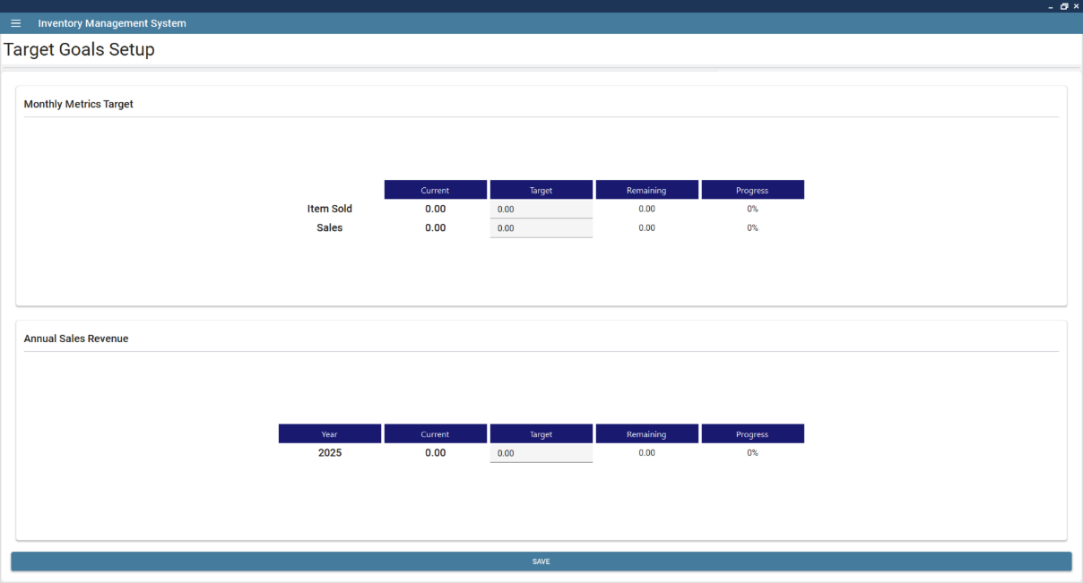

* *Overview of the Target Goals Setup Page*

The **Target Goals Setup Page** consists of two sections for setting performance targets:

* 1. **Monthly Metrics Target**

This section allows users to define **monthly sales targets** for:

* + - **Item Sold** – The target number of units to be sold within a month.
    - **Sales** – The revenue target for the month.

Each metric has the following columns:

* + - **Current** – The actual value achieved so far.
    - **Target** – The desired goal set by the user.
    - **Remaining** – The difference between the current value and the target.
    - **Progress (%)** – The percentage of completion towards the target.
  1. **Annual Sales Revenue**

This section helps users set **yearly sales revenue goals**, with similar columns as the monthly target:

* + - **Current** – The actual revenue earned for the year.
    - **Target** – The total sales goal for the year.
    - **Remaining** – The remaining amount needed to reach the goal.
    - **Progress (%)** – The percentage of completion.

At the bottom of the page, there is a **"Save"** button to store the entered target values.

* **Settings**: Configure system preferences.
* **Key Features and Their Functions**

1. **Bill Type Management**

This module allows users to define and manage different types of bills related to purchases, payments, and vendor transactions. This feature ensures proper categorization of bills, aiding in financial tracking and reporting.

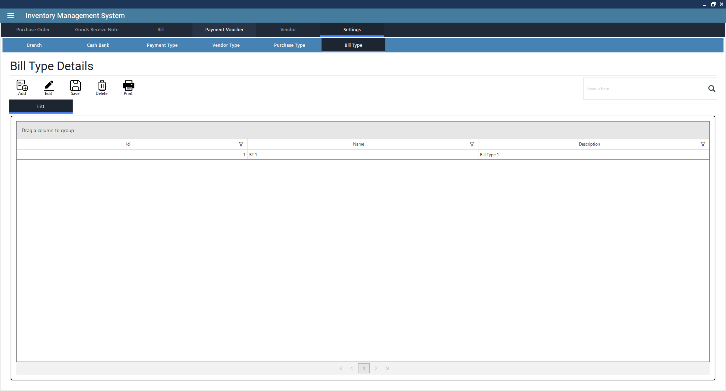

* + *Creating Bill Type*: Click on Add New, enter details and finalize. This will open a new form.
    1. Enter Bill Type Information
       - Name (Required: Unique identifier for the bill type)
       - Description (Optional: Additional details about the bill type)
    2. Save the Bill Type
       - Click Save to store the new bill type in the system.
    3. Printing or Further Processing
       - If needed, click Print to generate a report of all bill types.
  + *Editing Bill Type*: Click from the list to select a bill type, then click Edit to modify its details. (Note: The process is the same as creating a bill type.)
  + *Deleting Bill Type*: Click from the list to select a bill type, then click Delete to remove it.
  + *Saving Bill Type*: Click Save to confirm modifications.
  + *Generating Reports*: Click Print to generate a report on all bill types.

1. **Branch Management**

This module enables users to manage multiple business locations efficiently. This feature allows organizations to track inventory, sales, and purchases per branch, ensuring accurate reporting and streamlined operations.

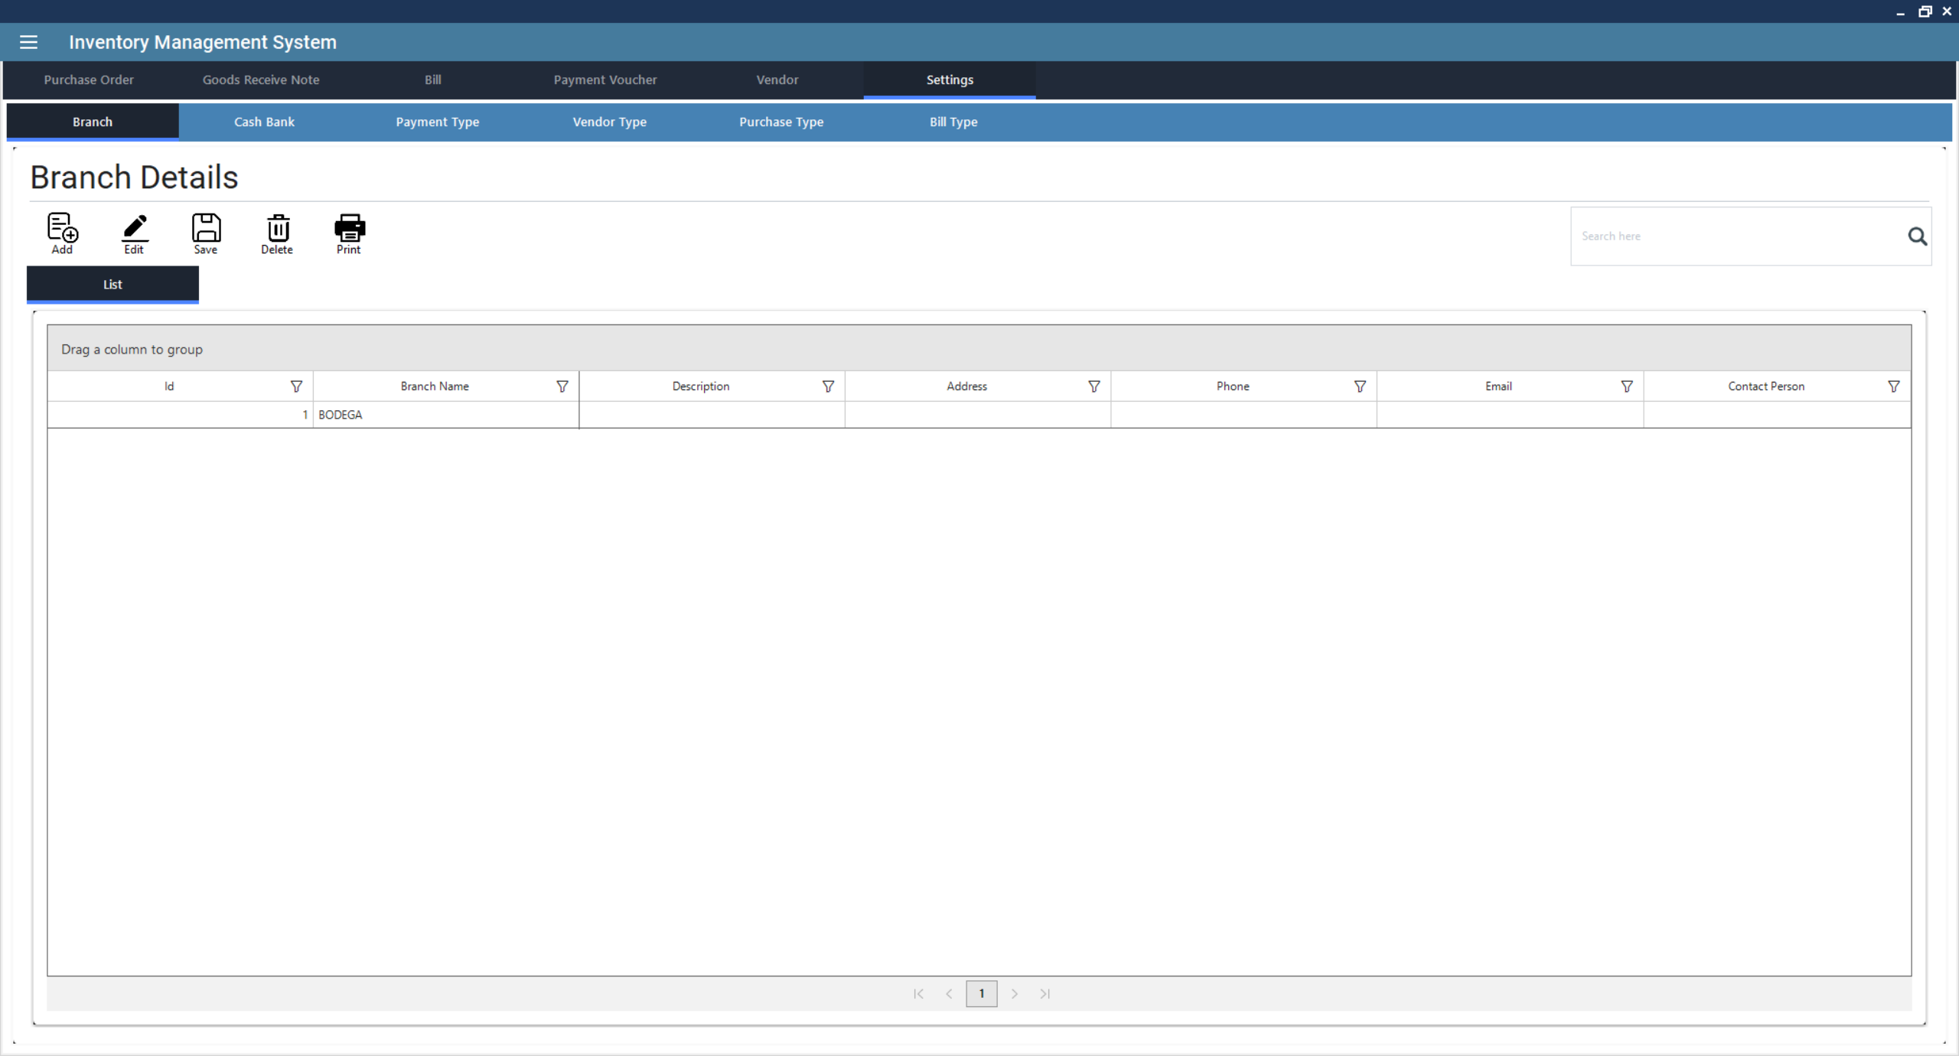

* + *Creating Branch*: Click on Add New, enter details and finalize. This will open a new form.
    1. Enter Branch Information
       - Name (Required: Unique identifier for the Branch)
       - Description (Optional: Additional details about the Branch)
       - Address (Optional)
       - Phone Number (Required)
       - Email Address (Optional)
       - Contact Person (Optional)
    2. Save the Branch
       - Click Save to store the new branch in the system.
    3. Printing or Further Processing
       - If needed, click Print to generate a report of all Branches.
  + *Editing Branch*: Click from the list to select a Branch, then click Edit to modify its details. ***(Note: The process is the same as creating a Branch.)***
  + *Deleting Branch*: Click from the list to select a Branch, then click Delete to remove it.
  + *Saving Branch*: Click Save to confirm modifications.
  + *Generating Reports*: Click Print to generate a report of all Branches.

1. **Cash Bank Management**

This module enables users to manage **cash and bank transactions**, ensuring efficient financial tracking and reconciliation. This feature helps businesses maintain accurate records of payments, deposits, withdrawals, and account balances.

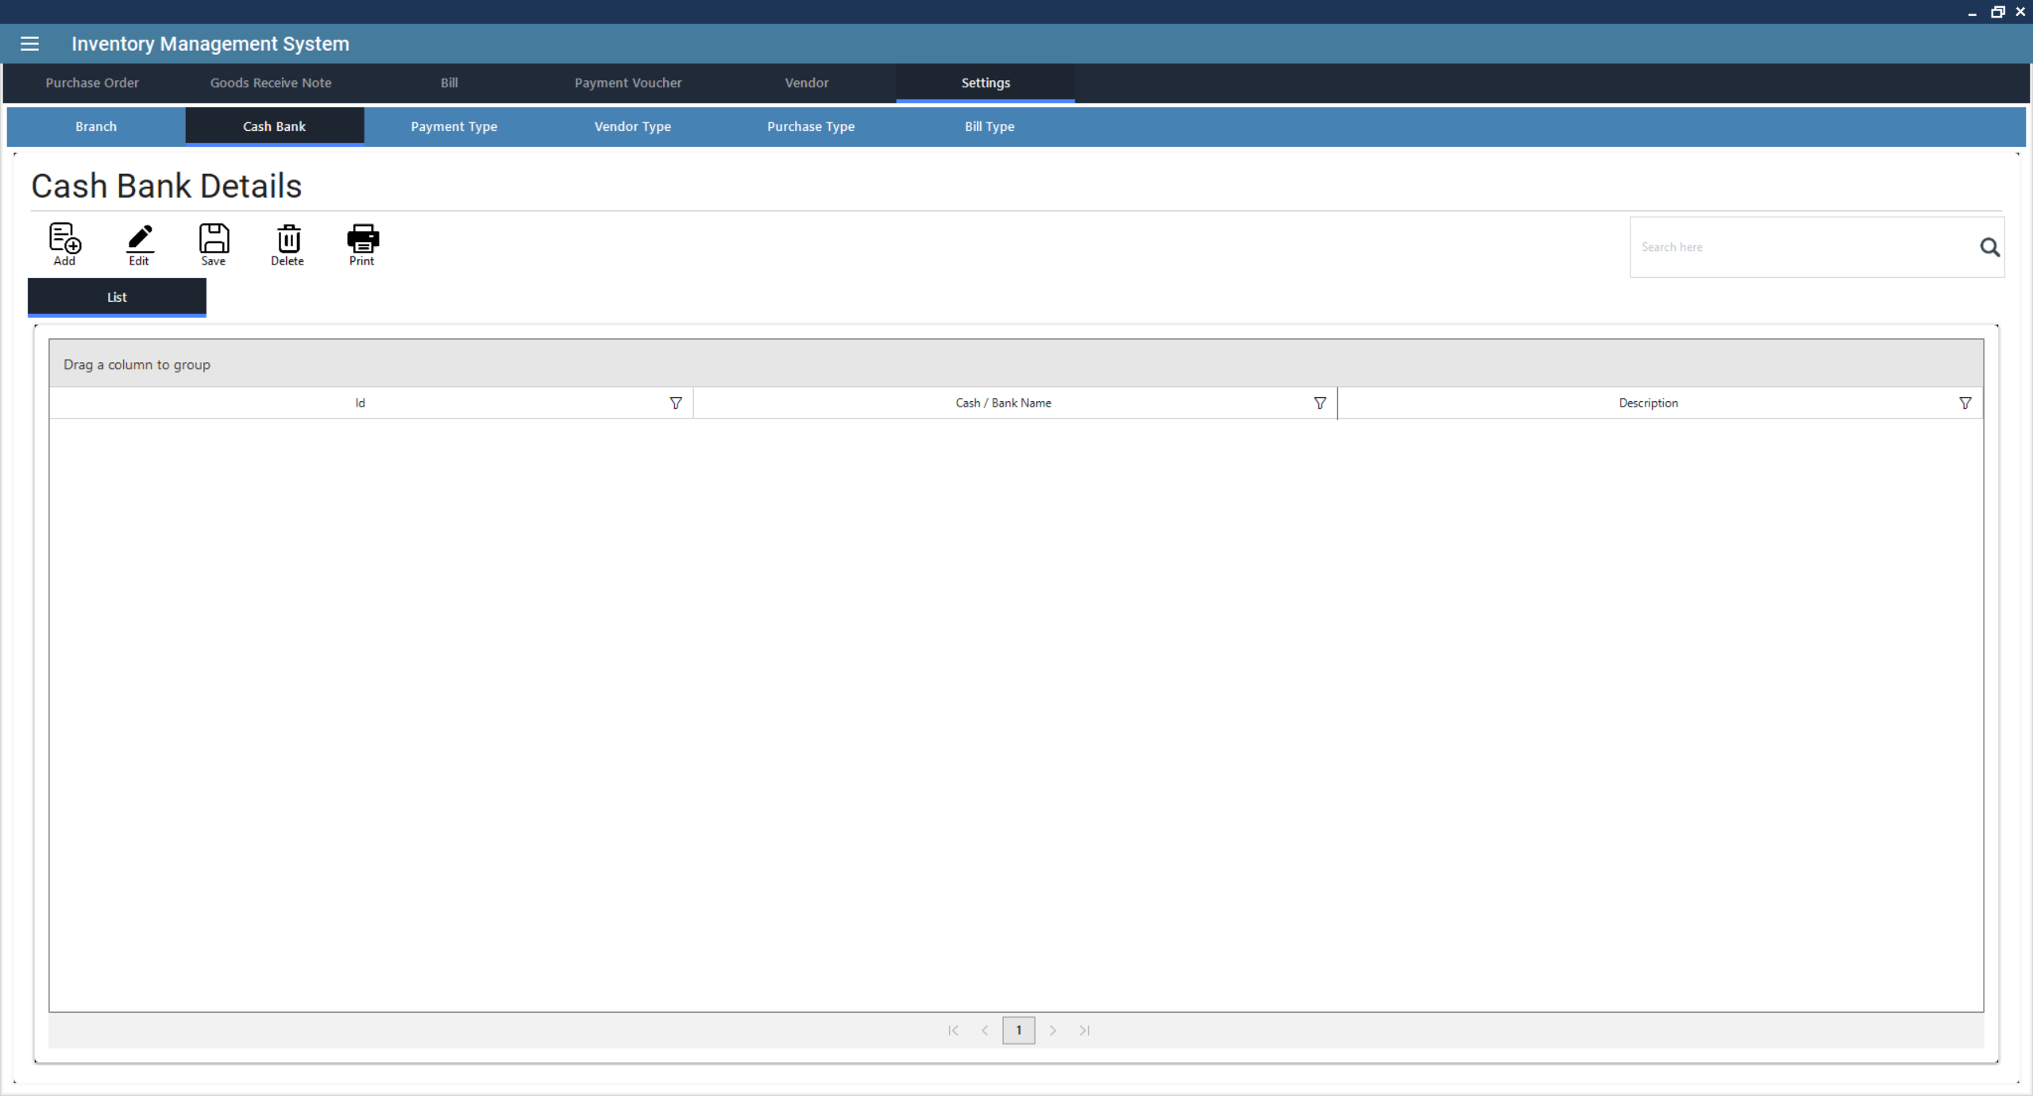

* + *Creating Cash Bank*: Click on Add New, enter details and finalize. This will open a new form.
    1. Enter Cash Bank Information
       - Name (Required: Unique identifier for the Cash Bank)
       - Description (Optional: Additional details about the Cash Bank)
    2. Save the Cash Bank
       - Click Save to store the new Cash Bank in the system.
    3. Printing or Further Processing
       - If needed, click Print to generate a report of all Cash Bank.
  + *Editing Cash Bank*: Click from the list to select a Cash Bank, then click Edit to modify its details. *(Note: The process is the same as creating a Cash Bank.)*
  + *Deleting Cash Bank*: Click from the list to select a Cash Bank, then click Delete to remove it.
  + *Saving Cash Bank*: Click Save to confirm modifications.
  + *Generating Reports*: Click Print to generate a report of all Cash Banks.

1. **Customer Management**

This module allows users to efficiently **store, track, and manage customer records**, ensuring smooth sales operations and customer relationship management.

* + *Creating Customer*: Click on **Add New**, enter details and finalize. This will open a new form.
    1. Enter Customer Information
       - Customer Name (Required field)
       - Customer Type (Dropdown selection)
       - Address (Optional)
       - Phone Number (Required)
       - Email Address (Optional)
       - Contact Person (Optional)
    2. Save the Customer
       - Click Save to store the customer information in the system.
    3. Printing or Further Processing
       - If needed, click Print to generate a report of all customers.
  + *Editing Customer*: Click from the list to select a customer, then click Edit to modify details. *(Note: The process is the same as creating a customer.)*
  + *Deleting Customer*: Click from the list to select a customer, then click Delete to remove them.
  + *Saving Customer*: Click Save to confirm modifications.
  + *Generating Reports*: Click Print to generate a report of all customers.

1. **Invoice Type Management**

This module allows users to define and manage different types of invoices for sales transactions. This feature ensures proper **categorization of invoices**, helping businesses maintain accurate billing records and generate detailed financial reports.

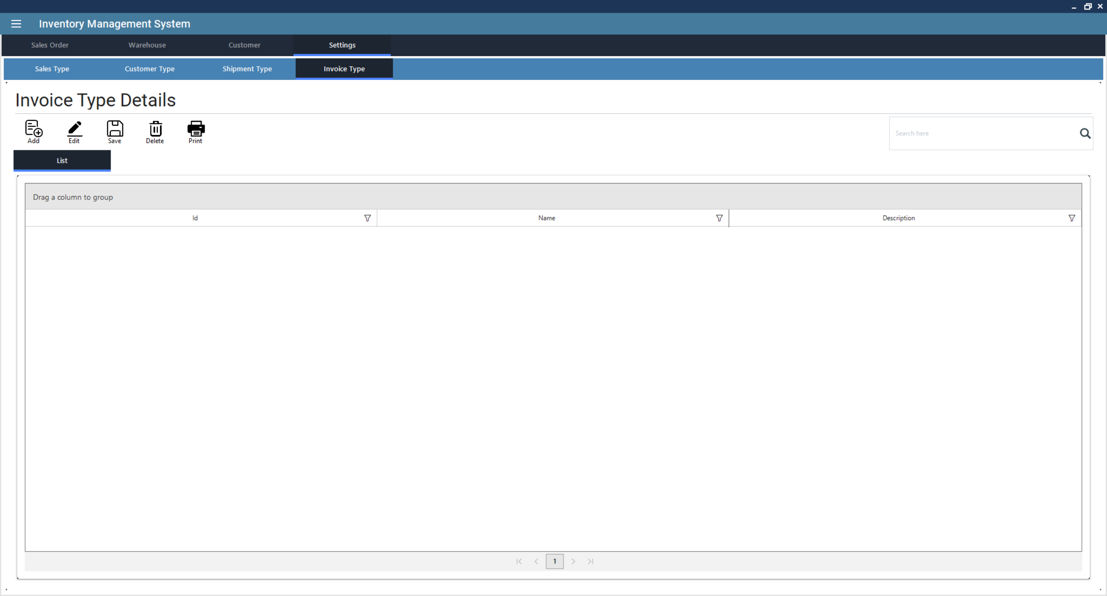

* + *Creating Invoice Type*: Click on Add New, enter details and finalize. This will open a new form.
    1. Enter Invoice Type Information
       - Name (Required: Unique identifier for the Invoice Type)
       - Description (Optional: Additional details about the Invoice Type)
    2. Save the Invoice Type
       - Click Save to store the new Invoice Type in the system.
    3. Printing or Further Processing
       - If needed, click Print to generate a report of all Invoice Types.
  + *Editing Invoice Type*: Click from the list to select a Invoice Type, then click Edit to modify its details. ***(Note: The process is the same as creating a Invoice Type.)***
  + *Deleting Invoice Type*: Click from the list to select a Invoice Type, then click Delete to remove it.
  + *Saving Invoice Type*: Click Save to confirm modifications.
  + *Generating Reports*: Click Print to generate a report of all Invoice Types.

1. **Product Type Management**

This module allows users to categorize products based on their type, making it easier to manage, track, and analyze inventory. This feature helps businesses streamline product classification, pricing strategies, and reporting.

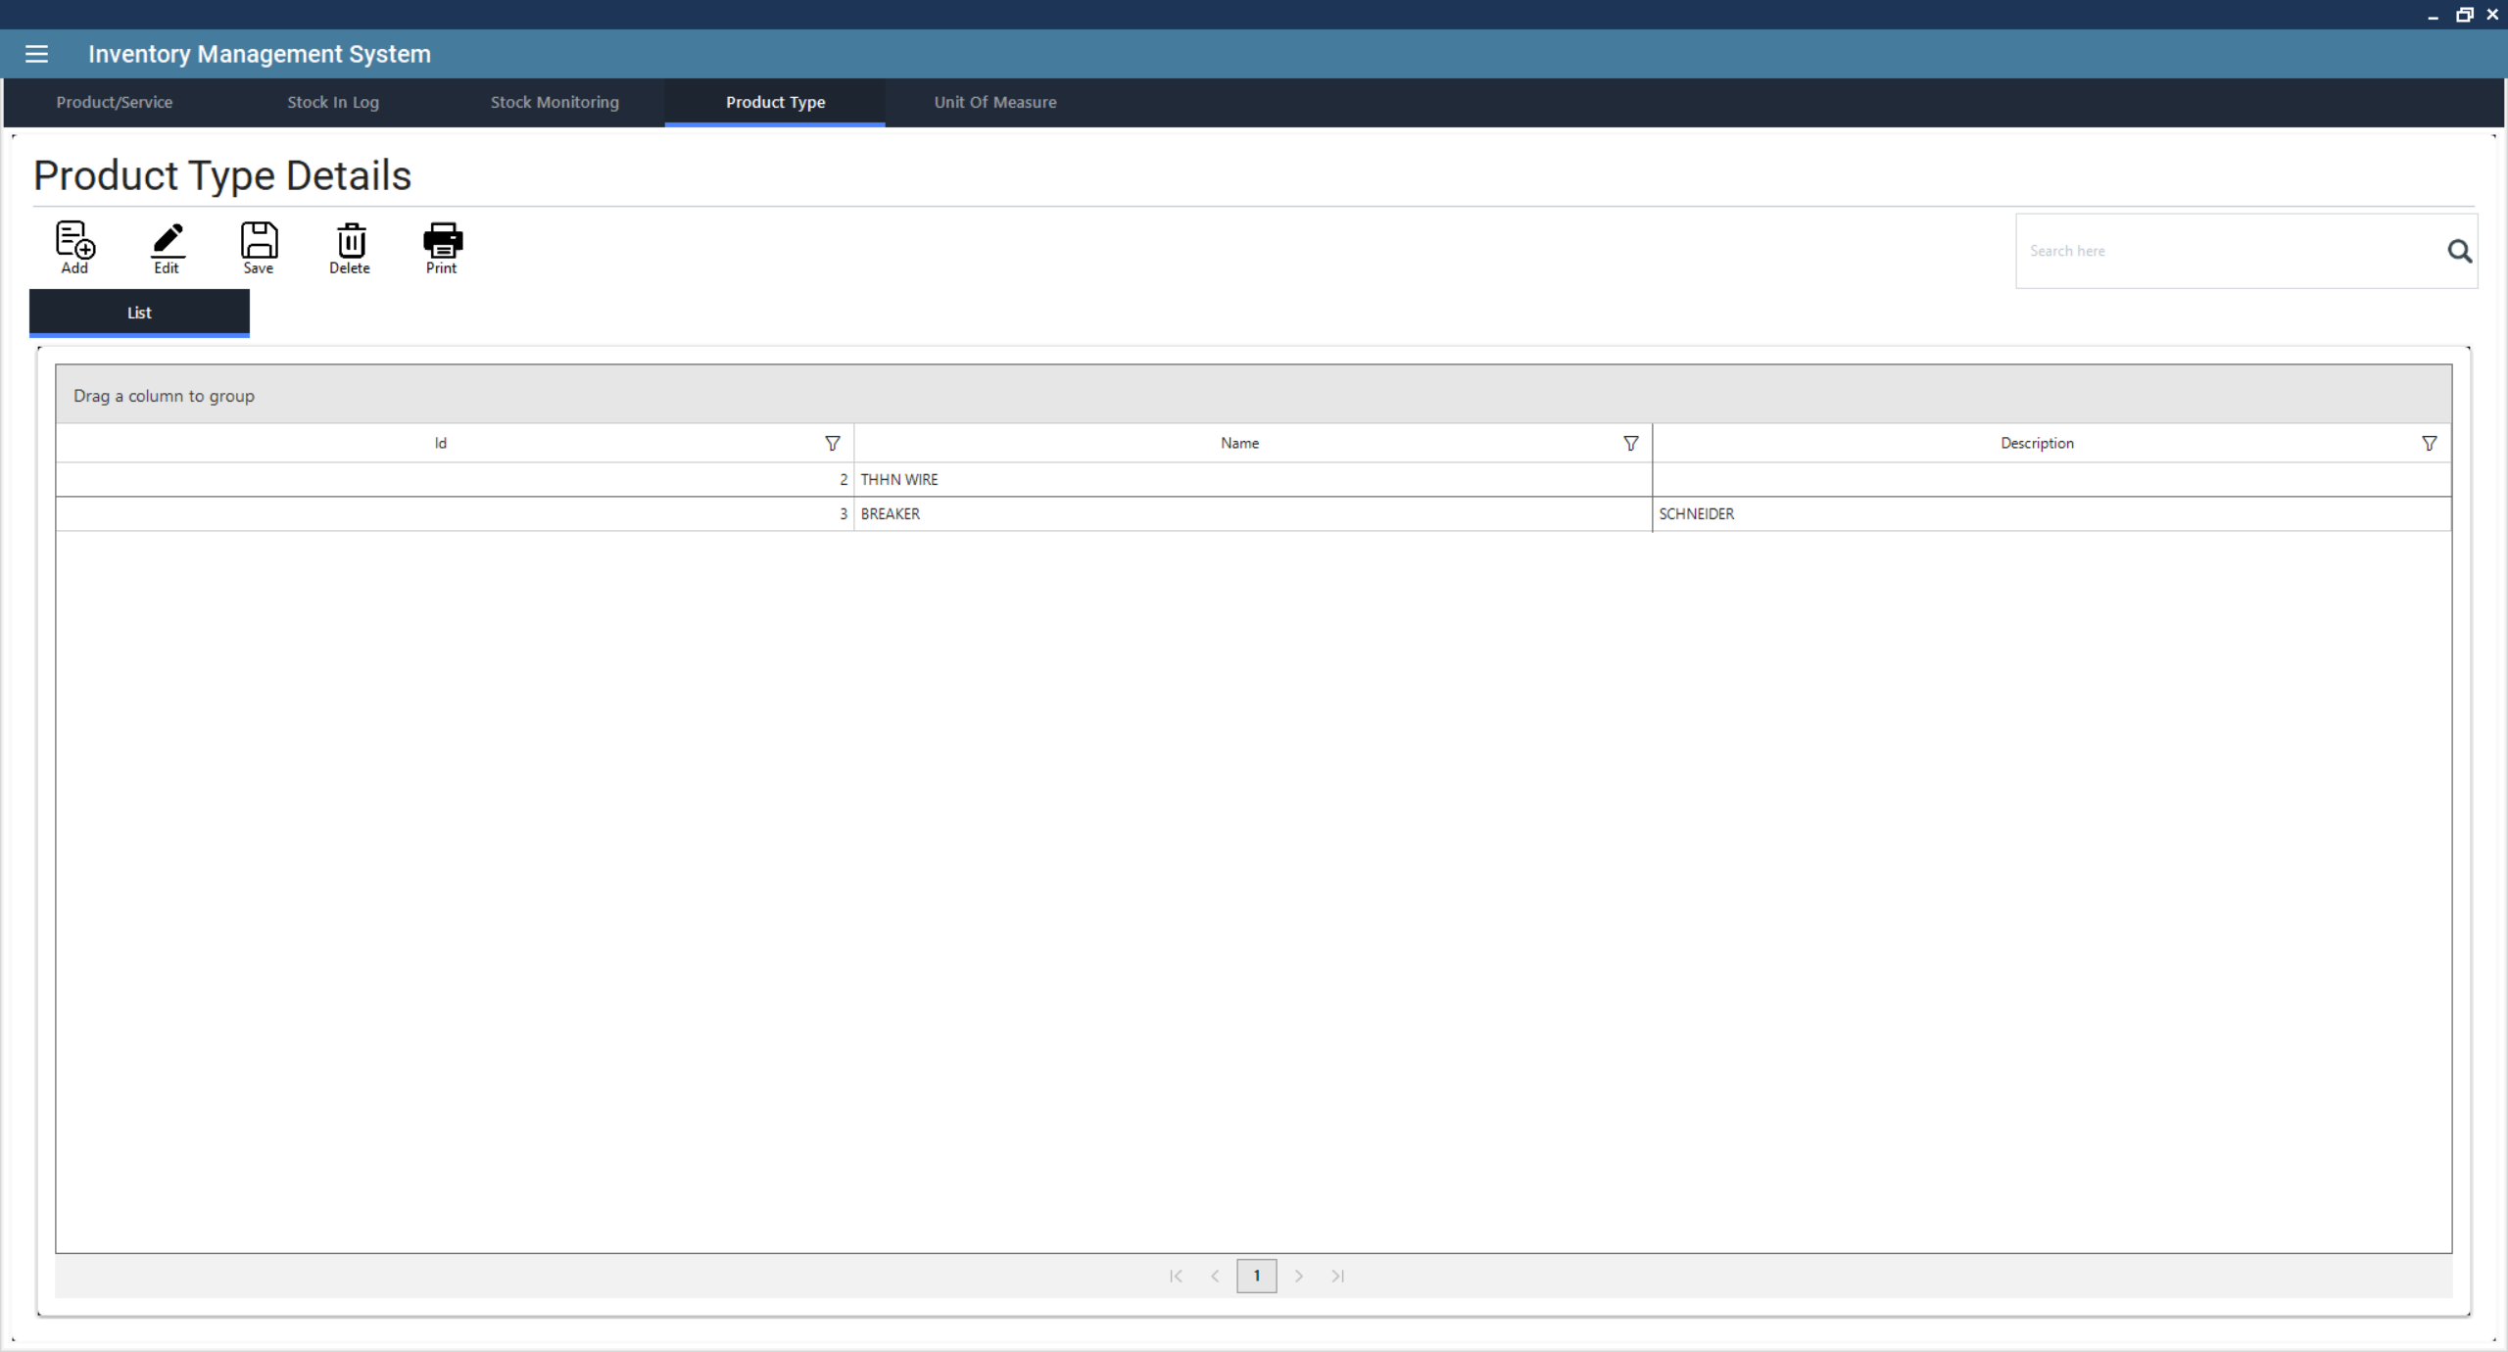

* + *Creating Product Type*: Click on Add New, enter details and finalize. This will open a new form.
    1. Enter Product Type Information
       - Name (Required: Unique identifier for the Product Type)
       - Description (Optional: Additional details about the Product Type)
    2. Save the Product Type
       - Click Save to store the new Product Type in the system.
    3. Printing or Further Processing
       - If needed, click Print to generate a report of all Product Type.
  + *Editing Product Type*: Click from the list to select a Product Type, then click Edit to modify its details. *(Note: The process is the same as creating a Product Type.)*
  + *Deleting Product Type*: Click from the list to select a Product Type, then click Delete to remove it.
  + *Saving Product Type*: Click Save to confirm modifications.
  + *Generating Reports*: Click Print to generate a report of all Product Types.

1. **Product Management**

This module allows users to efficiently **add, track, and manage inventory items**, ensuring accurate stock control, pricing, and reporting.

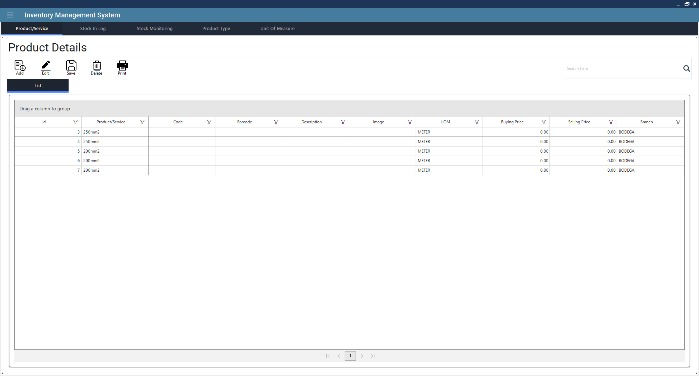

* + *Creating Product*: Click on Add New, enter details and finalize. This will open a new form.
    1. Ensure a Product Type, Branch and Unit of Measure are Created First
       - Products must be assigned to a Branches.
       - Navigate to the Branch Management section and create a new branch if necessary.
       - Navigate to the Product Type and Unit of Measure and create new if necessary.
    2. Enter Product Information
       - Name (Required: Unique identifier for the Product)
       - Description (Optional: Additional details about the Product)
       - Code (Optional)
       - Barcode (Optional)
       - Product Type (refer to Product Type Management)
       - Brand (Optional)
       - Color (Optional)
       - Size (Optional)
       - Unit of Measure (refer to Unit of Measure Management)
       - Branch (refer to Branch Management)
       - Reorder Level
       - Default Buying Price
       - Default Selling Price
    3. Save the Product
       - Click Save to store the new Product in the system.
    4. Printing or Further Processing
       - If needed, click Print to generate a report of all Product.
  + *Editing Product*: Click from the list to select a Product, then click Edit to modify its details. *(Note: The process is the same as creating a Product.)*
  + *Deleting Product*: Click from the list to select a Product, then click Delete to remove it.
  + *Saving Product*: Click Save to confirm modifications.
  + *Generating Reports*: Click Print to generate a report of all Products.

1. **Purchase Orders**

This module enables businesses to efficiently track and manage their **procurement process**, ensuring smooth supplier transactions and stock replenishment.

* + *Creating Purchase Orders*: Click on Add New, enter supplier details, add products, and finalize and this will open a new purchase order form.
    1. Enter Purchase Information
       - Purchase Order Number (Auto-generated)
       - Purchase Type (Dropdown selection)
       - Branch (Select from available branches)
       - Order Date
       - Delivery Date
       - Vendor (Select or add a new vendor)
       - Remarks (Optional additional details)
    2. Add Items to the Purchase Order
       - Click on the Purchase Order Line section.
       - Select the Product from the dropdown list.
       - Specify Quantity and apply any Discount if applicable.
       - Click the Add button to include the item in the order.
    3. Review Payment Details
       - Navigate to the Payment Details section.
       - Verify Subtotal, Tax (12%), Freight, and Total Amount.
    4. Save the Purchase Order
       - Click **Save** to store the purchase order in the system.
    5. Printing or Further Processing
       - If needed, click Print to generate a physical or digital copy of the purchase order.
       - You can later process GRN (Goods Received Note), Bill, or Payment Voucher using the respective buttons.
  + *Editing Purchase Orders*: Click from the list to select a purchase order, then click the Edit button to modify details. *(Note: Process is the same when creating purchase order)*
  + *Deleting Purchase Orders*: Click from the list to select a purchase order, then click the Delete button to remove it.
  + *Saving Purchase Orders*: Click Save to confirm modifications. *(Note: This will only work when you are creating or editing)*
  + *Printing Purchase Orders*: Click the Print button to generate a purchase order report.
  + *Generating GRN (Goods Received Note)*: Click from the list to select a purchase order, then click the GRN button to create a record of received goods.
  + *Billing and Voucher*: Click from the list to select a purchase order, then click the Bill button to process supplier invoices and click Voucher to generate payment vouchers.

1. **Sales Orders**

This module enables businesses to efficiently **create, track, and manage sales transactions**, ensuring smooth order processing and fulfillment.

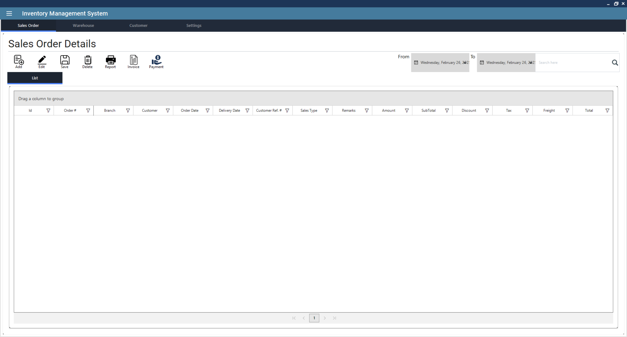

* + *Creating Sales Orders*: Click on **Add New**, enter customer details, add products, and finalize. This will open a new sales order form.
    1. Enter Sales Information
       - Sales Order Number
       - Sales Type (Dropdown selection)
       - Branch (Select from available branches)
       - Sales Order Date
       - Delivery Date
       - Customer (Select or add a new customer)
       - Customer Reference Number (Optional)
       - Remarks (Additional details)
    2. Add Items to the Sales Order
       - Click on the Sales Order Line section.
       - Select the Product from the dropdown list.
       - Specify Quantity and apply any Discount if applicable.
       - Click the Add button to include the item in the order.
    3. Review Shipment Details
       - Navigate to the Shipment Details section.
       - Select Shipment Type and Warehouse.
       - Choose Shipment Date.
       - Toggle Full Shipment if all items will be shipped.
    4. Review Payment Details
       - Navigate to the Payment Details section.
       - Verify Subtotal, Tax (12%), Freight, and Total Amount.
    5. Save the Sales Order
       - Click Save to store the sales order in the system.
    6. Printing or Further Processing
       - If needed, click Report to generate a summary report.
       - Click Invoice to generate a customer invoice.
       - Click Payment to confirm and process payments.
  + *Editing Sales Orders*: Click from the list to select a sales order, then click the **Edit** button to modify details. *(Note: The process is the same as creating a sales order.)*
  + *Deleting Sales Orders*: Click from the list to select a sales order, then click the Delete button to remove it.
  + *Saving Sales Orders*: Click Save to confirm modifications. (Note: This will only work when you are creating or editing.)
  + *Generating Reports*: Click Report to generate a summary report.
  + *Generating Invoices*: Click from the list to select a sales order, then click Invoice to create an invoice for the selected sales order.
  + *Processing Payments*: Click from the list to select a sales order, then click Payment to confirm the transaction and process customer payments.

1. **Shipment Type**

This module allows users to define and manage different types of shipment methods for **sales and purchase orders**, ensuring efficient logistics and delivery tracking.

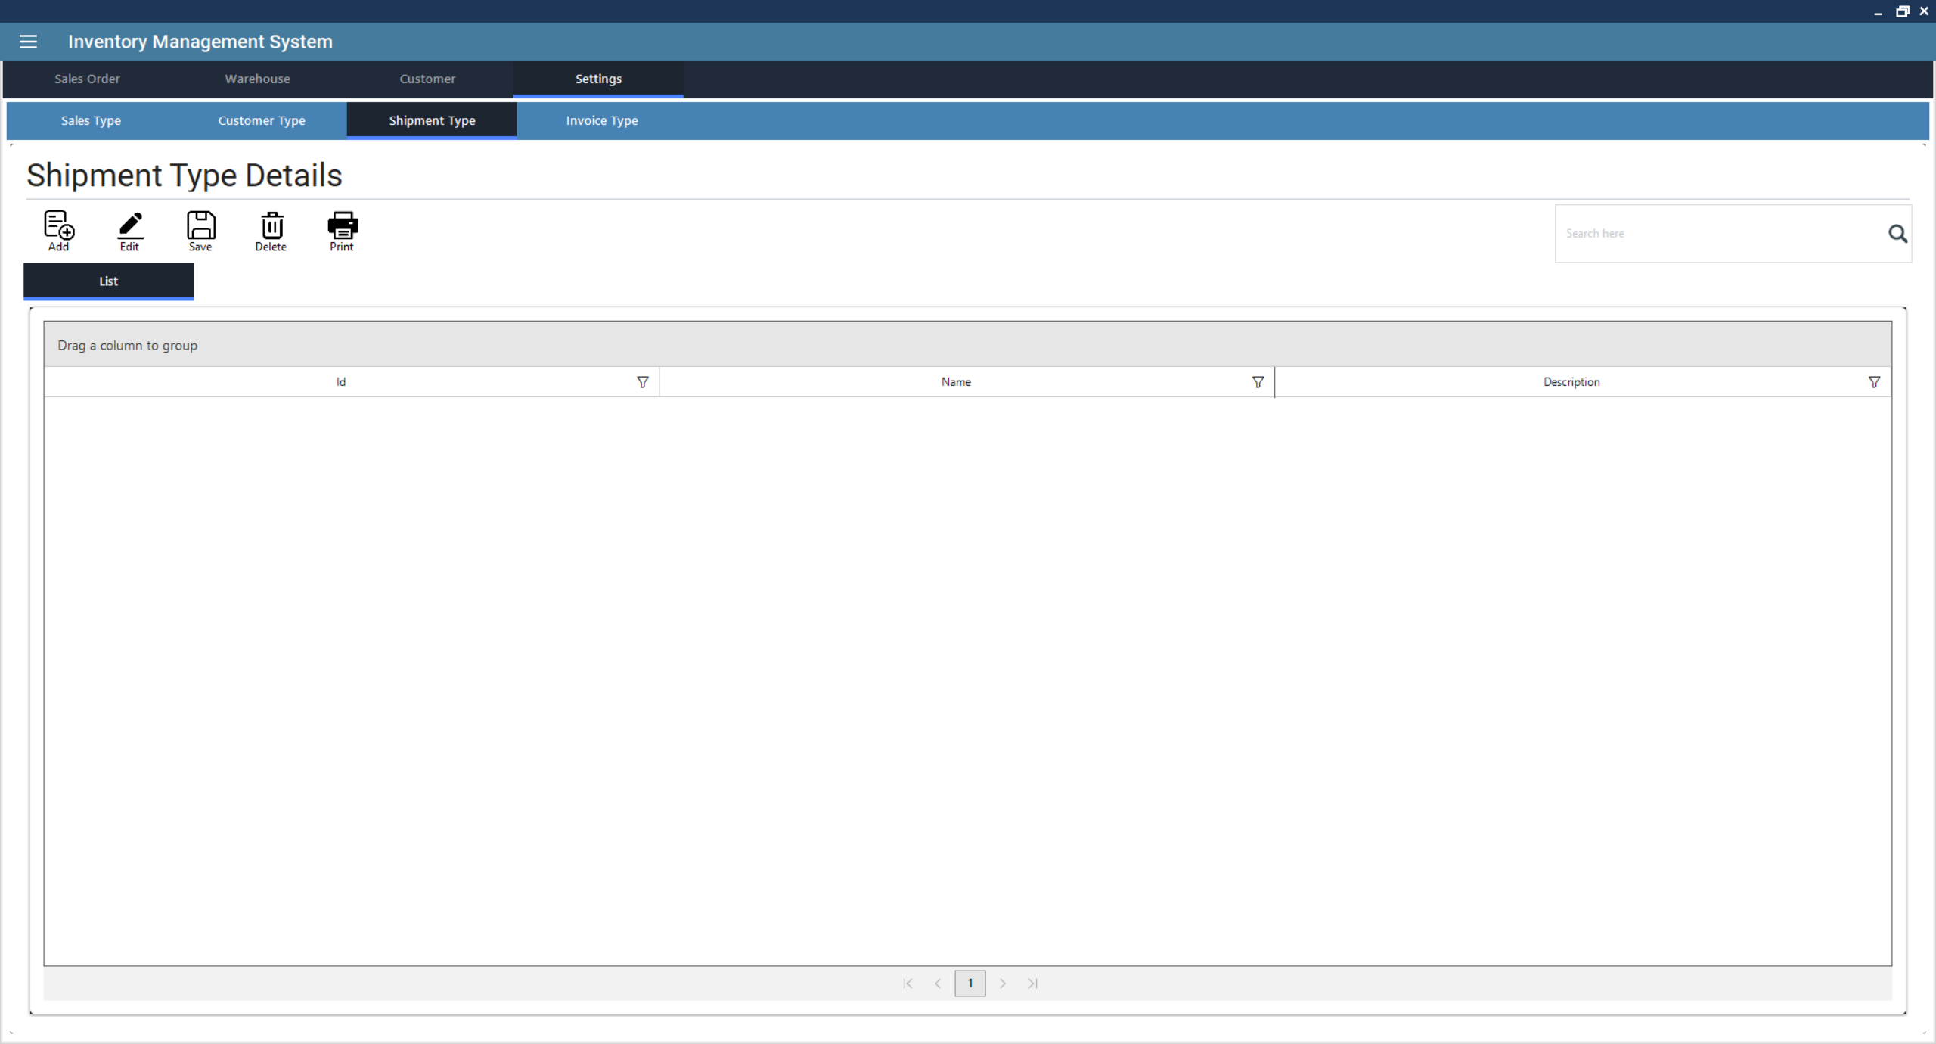

* + *Creating Shipment Type*: Click on Add New, enter details and finalize. This will open a new form.
    1. Enter Shipment Type Information
       - Name (Required: Unique identifier for the Shipment Type)
       - Description (Optional: Additional details about the Shipment Type)
    2. Save the Shipment Type
       - Click Save to store the new Shipment Type in the system.
    3. Printing or Further Processing
       - If needed, click Print to generate a report of all Shipment Type.
  + *Editing Shipment Type*: Click from the list to select a Shipment Type, then click Edit to modify its details. *(Note: The process is the same as creating a Shipment Type.)*
  + *Deleting Shipment Type*: Click from the list to select a Shipment Type, then click Delete to remove it.
  + *Saving Shipment Type*: Click Save to confirm modifications.
  + *Generating Reports*: Click Print to generate a report of all Shipment Types.

1. **Unit of Measurement (UOM)**

This module allows users to define and manage measurement units for **products and services**, ensuring accurate inventory tracking and sales processing.

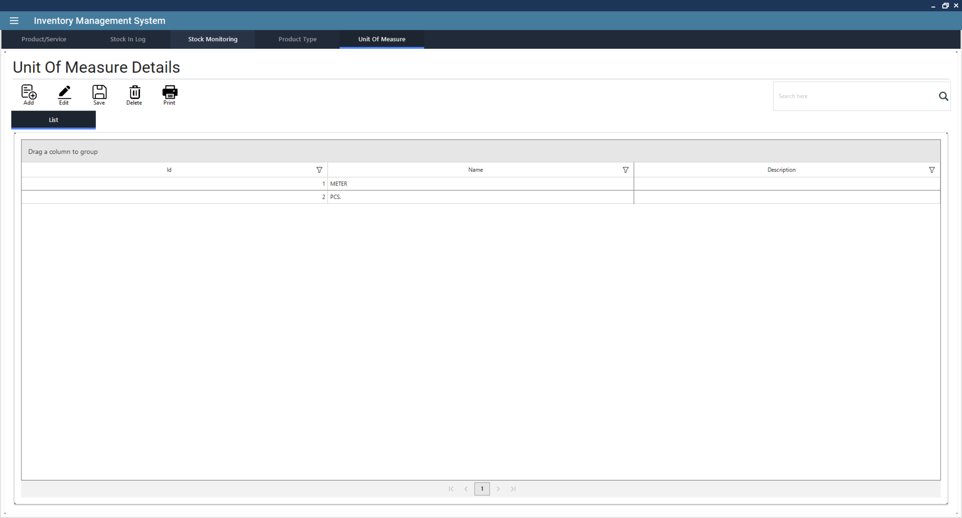

* + *Creating Unit of Measure*: Click on Add New, enter details and finalize. This will open a new form.
    1. Enter Unit of Measure Information
       - Name (Required: Unique identifier for the Unit of Measure)
       - Description (Optional: Additional details about the Unit of Measure)
    2. Save the Unit of Measure
       - Click Save to store the new Unit of Measure in the system.
    3. Printing or Further Processing
       - If needed, click Print to generate a report of all Unit of Measure.
  + *Editing Unit of Measure*: Click from the list to select a Unit of Measure, then click Edit to modify its details. *(Note: The process is the same as creating a Unit of Measure.)*
  + *Deleting Unit of Measure*: Click from the list to select a Unit of Measure, then click Delete to remove it.
  + *Saving Unit of Measure*: Click Save to confirm modifications.
  + *Generating Reports*: Click Print to generate a report of all Unit of Measures.

1. **Vendor Management**

This module allows users to efficiently **track, manage, and organize vendor relationships**, ensuring seamless procurement and payment processing.

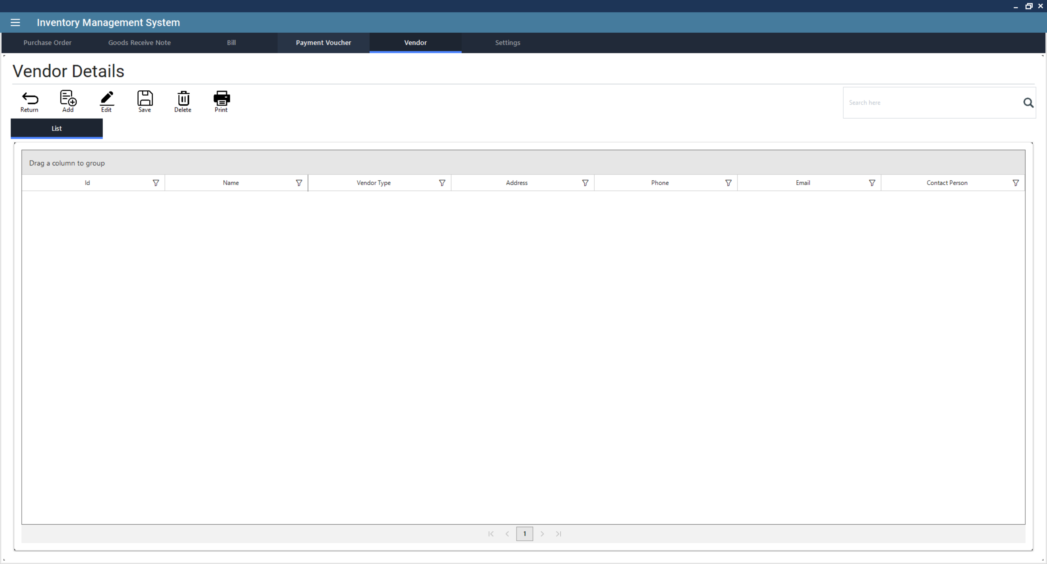

* + *Creating Vendor*: Click on Add New, enter details and finalize. This will open a new form.
    1. Ensure a Vendor Type is Created First
       - Navigate to the Vendor Type Management section and create a new vendor type if necessary.
    2. Enter Vendor Information
       - Name (Required: Unique identifier for the Vendor)
       - Vendor Type
       - Address (Optional)
       - Phone Number (Required)
       - Email Address (Optional)
       - Contact Person (Optional)
    3. Save the Vendor
       - Click Save to store the new Vendor in the system.
    4. Printing or Further Processing
       - If needed, click Print to generate a report of all Vendor.
  + *Editing Vendor*: Click from the list to select a Vendor, then click Edit to modify its details. *(Note: The process is the same as creating a Vendor.)*
  + *Deleting Vendor*: Click from the list to select a Vendor, then click Delete to remove it.
  + *Saving Vendor*: Click Save to confirm modifications.
  + *Generating Reports*: Click Print to generate a report of all Vendors.

1. **Warehouse Management**

This module allows users to efficiently track, manage, and organize **inventory storage across multiple warehouses**. This feature ensures accurate stock levels, optimized logistics, and streamlined warehouse operations.

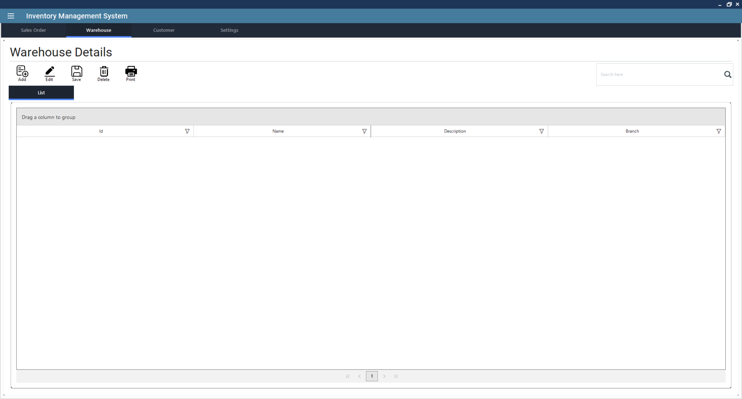

* + *Creating Warehouse*: Click on **Add New**, enter details and finalize. This will open a new warehouse form.
    1. Ensure a Branch is Created First
       - Warehouses must be assigned to a branch.
       - Navigate to the Branch Management section and create a new branch if necessary.
    2. Enter Warehouse Details
       - Warehouse Name (Unique name for identification)
       - Description (Optional, for additional details)
       - Branch (Select from available branches)
    3. Click Save to store the new warehouse information in the system.

Printing or Further Processing

* + 1. If needed, click Print to generate a report of all warehouses.
  + *Editing Warehouse*: Click from the list to select a warehouse, then click Edit to modify its details. *(Note: The process is the same as creating a warehouse.)*
  + *Deleting Warehouse*: Click from the list to select a warehouse, then click Delete to remove it.
  + *Saving Warehouse*: Click Save to confirm modifications.
  + *Generating Reports*: Click Print to generate a report of all warehouses.

1. **Payroll Module**

This module enables businesses to efficiently **manage employee salaries, deductions, benefits, and payroll reports**. This feature ensures accurate payroll processing, compliance with tax regulations, and smooth salary disbursement.

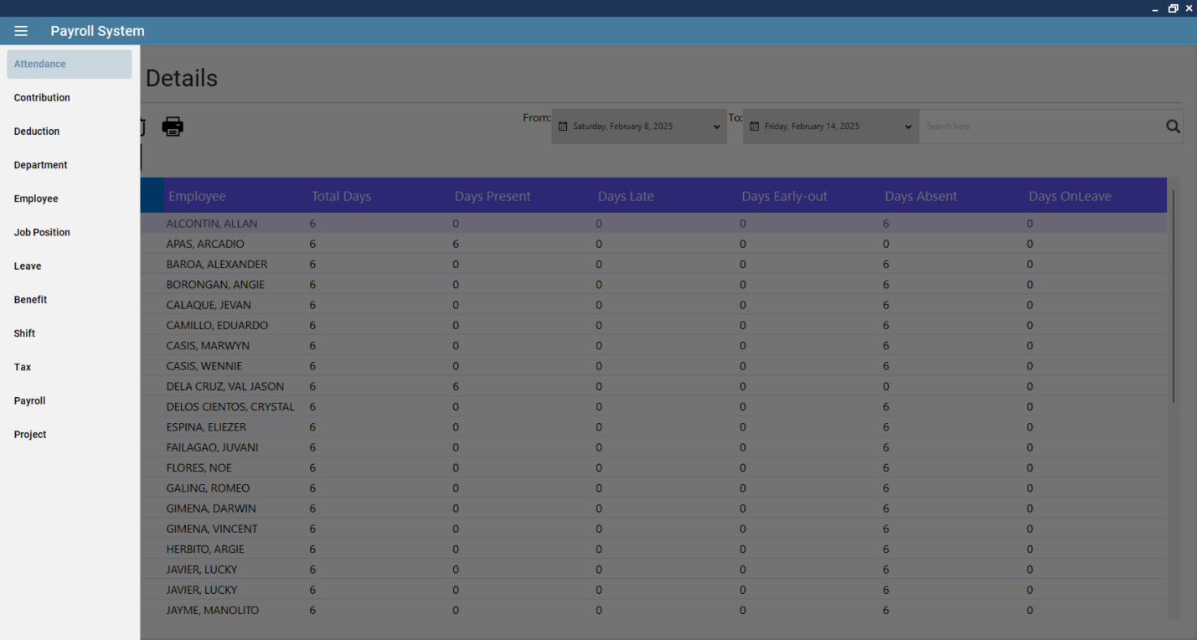

* **Key Features and Their Functions**

1. **Allowance Management**

This module enables businesses to **define, track, and manage employee allowances**. This feature ensures accurate payroll processing by including **additional earnings** such as transport, housing, and meal allowances in employee salaries.

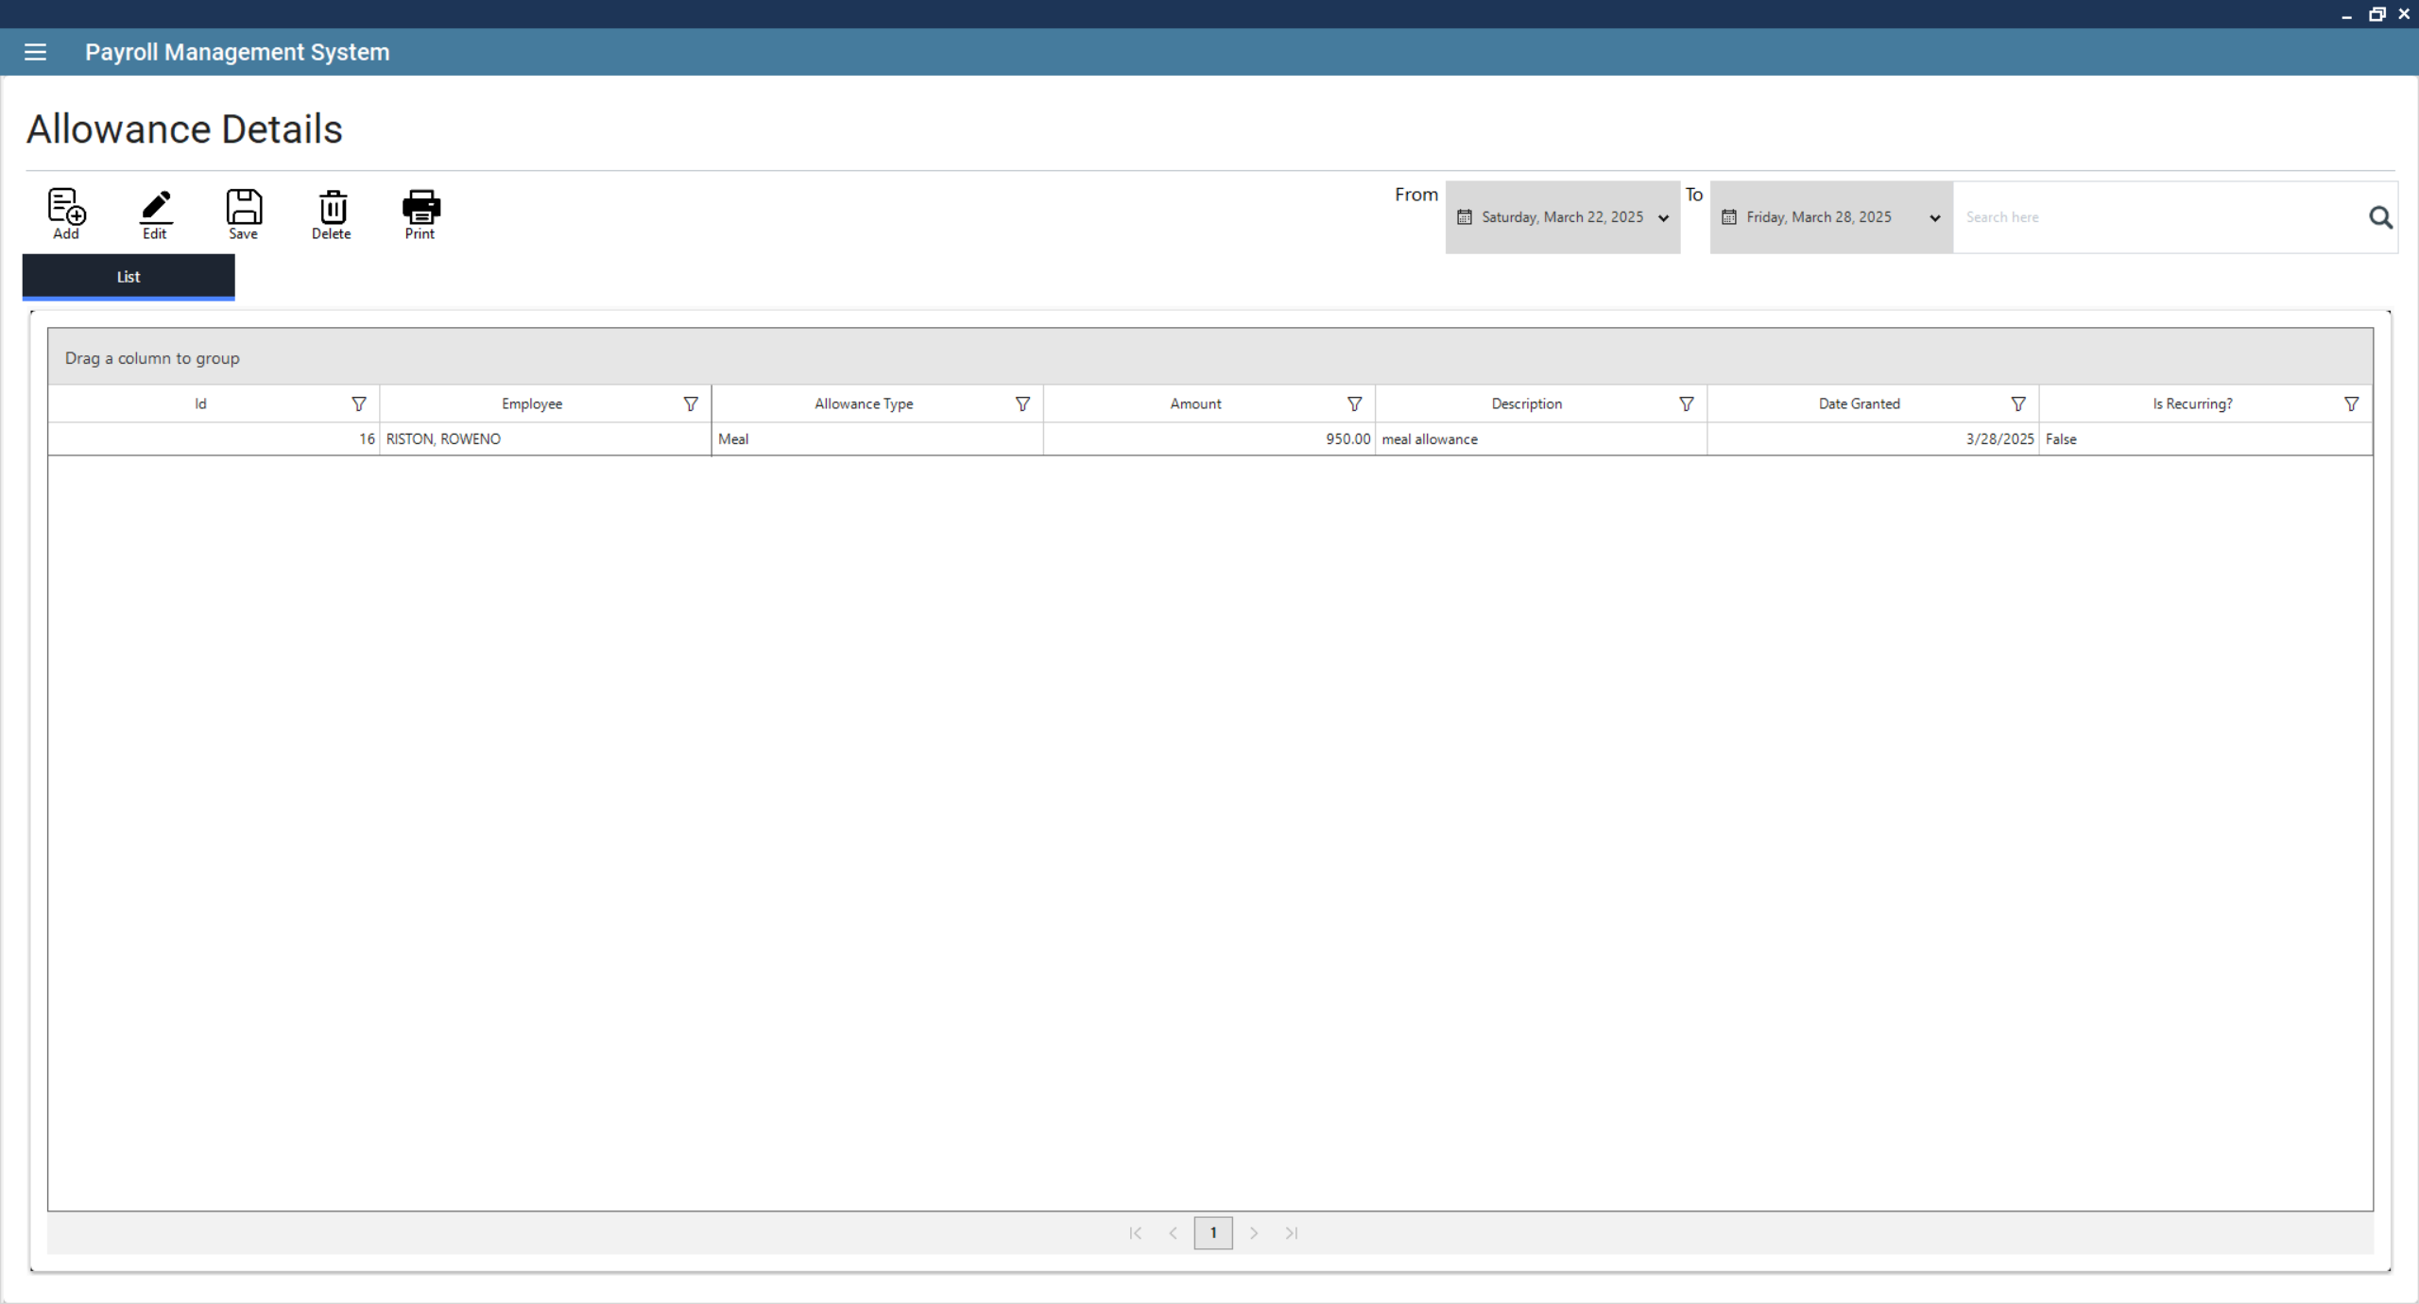

* + *Creating Allowance*: Click on Add New, enter details and finalize. This will open a new form.
    1. Ensure an Employee is Created First.
       - Navigate to the Employee Management section and create a new employee if necessary.
    2. Enter Allowance Information
       - Select Employee
       - Select Allowance Type
       - Date Granted
       - Amount
       - Description (Optional)
    3. Save the Allowance
       - Click Save to store the new Allowance in the system.
    4. Printing or Further Processing
       - If needed, click Print to generate a report of all Allowance.
  + *Editing Allowance*: Click from the list to select a Allowance, then click Edit to modify its details. *(Note: The process is the same as creating an Allowance.)*
  + *Deleting Allowance*: Click from the list to select a Allowance, then click Delete to remove it.
  + *Saving Allowance*: Click Save to confirm modifications.
  + *Generating Reports*: Click Print to generate a report of all Allowances.

1. **Attendance Management**

This module allows businesses to **track employee working hours, leaves, overtime, and absences** to ensure accurate payroll processing. This feature helps organizations maintain **productivity records, enforce company policies, and streamline salary calculations**.

* + *Creating Attendance*: Click on Add New, enter details and finalize. This will open a new form.
    1. Enter Attendance Information
       - Select Employee
       - Select Project
       - Date
       - Time-in
       - Time-out
       - Hours Worked (Include O.T.)
       - Present? (Toggle button if present or not)
       - Half-day? (Toggle button if half-day or not)
    2. Save the Attendance
       - Click Save to store the new Attendance in the system.
    3. Printing or Further Processing
       - If needed, click Print to generate a report of all Attendance.
  + *Editing Attendance*: Click from the list to select a Attendance, then click Edit to modify its details. *(Note: The process is the same as creating a Attendance.)*
  + *Deleting Attendance*: Click from the list to select a Attendance, then click Delete to remove it.
  + *Saving Attendance*: Click Save to confirm modifications.
  + *Generating Reports*: Click Print to generate a report of all Attendances.
  + *Checking Individual Attendance*: Use the date filter to specify a date range.A screenshot of a computer

    AI-generated content may be incorrect.Double click on a record to review attendance details. To edit individual attendance, you must click the generated individual employee attendance summary and select the entry and press **Edit**.

If needed, manually adjust work hours, the correct hours, and saving the changes. The system also allows searching for a specific employee’s attendance using the search bar.

1. **Employee Benefits Management**

This module enables businesses to **define, track, and manage employee benefits**, ensuring fair compensation and compliance with labor policies. This feature helps companies improve **employee satisfaction, retention, and payroll accuracy**.

* + *Creating Benefits*: Click on Add New, enter details and finalize. This will open a new form.
    1. Enter Benefits Information
       - Select Employee
       - Benefit Type
       - Amount
       - If Others (Optional: used if benefit type is other)
    2. Save the Benefits
       - Click Save to store the new Benefits in the system.
    3. Printing or Further Processing
       - If needed, click Print to generate a report of all Benefits.
  + *Editing Benefits*: Click from the list to select a Benefits, then click Edit to modify its details. *(Note: The process is the same as creating Benefits.)*
  + *Deleting Benefits*: Click from the list to select a Benefits, then click Delete to remove it.
  + *Saving Benefits*: Click Save to confirm modifications.
  + *Generating Reports*: Click Print to generate a report of all Benefits.

1. **Employee Contribution Management**

This module allows businesses to **track, manage, and process employee contributions** for social security, insurance, retirement plans, and other deductions. This feature ensures **accurate payroll calculations, compliance with labor laws, and proper financial tracking**.

* + *Creating Contribution*: Click on Add New, enter details and finalize. This will open a new form.
    1. Enter Contribution Information
       - Select Employee
       - SSS
       - SSS – Mandatory Provident Fund (WISP)
       - Pag-ibig
       - PhilHealth
    2. Save the Contribution
       - Click Save to store the new Contribution in the system.
    3. Printing or Further Processing
       - If needed, click Print to generate a report of all Contribution.
  + *Editing Contribution*: Click from the list to select a Contribution, then click Edit to modify its details. *(Note: The process is the same as creating a Contribution.)*
  + *Deleting Contribution*: Click from the list to select a Contribution, then click Delete to remove it.
  + *Saving Contribution*: Click Save to confirm modifications.
  + *Generating Reports*: Click Print to generate a report of all Contributions.

1. **Salary Deduction Management**

This module allows businesses to **track, manage, and apply deductions to employee salaries** for various reasons such as taxes, loans, and penalties. This feature ensures **accurate payroll processing and compliance with company policies and legal requirements**.

* + *Creating Deduction*: Click on Add New, enter details and finalize. This will open a new form.
    1. Enter Deduction Information
       - Select Employee
       - Deduction Type
       - Date Deducted
       - Amount
       - Description
    2. Save the Deduction
       - Click Save to store the new Deduction in the system.
    3. Printing or Further Processing
       - If needed, click Print to generate a report of all Deduction.
  + *Editing Deduction*: Click from the list to select a Deduction, then click Edit to modify its details. *(Note: The process is the same as creating a Deduction.)*
  + *Deleting Deduction*: Click from the list to select a Deduction, then click Delete to remove it.
  + *Saving Deduction*: Click Save to confirm modifications.
  + *Generating Reports*: Click Print to generate a report of all Deductions.

1. **Department Management**

This module allows businesses to efficiently **organize employees and operations by department**, ensuring proper payroll processing, role assignments, and reporting.

* + *Creating Department*: Click on Add New, enter details and finalize. This will open a new form.
    1. Enter Department Information
       - Name (Required: Unique identifier for the Department)
       - Description (Optional: Additional details about the Department)
    2. Save the Department
       - Click Save to store the new Department in the system.
    3. Printing or Further Processing
       - If needed, click Print to generate a report of all Department.
  + *Editing Department*: Click from the list to select a Department, then click Edit to modify its details. *(Note: The process is the same as creating a Department.)*
  + *Deleting Department*: Click from the list to select a Department, then click Delete to remove it.
  + *Saving Department*: Click Save to confirm modifications.
  + *Generating Reports*: Click Print to generate a report of all Departments.

1. **Employee Management**

This module system allows businesses to **store, track, and manage employee records**, ensuring efficient payroll processing, role assignments, and HR operations.

* + *Creating Employee*: Click on Add New, enter details and finalize. This will open a new form.
    1. Enter Employee Information
       - First Name (Required: Unique identifier for the Employee)
       - Last Name (Required: Unique identifier for the Employee)
       - Gender
       - Contact Number
       - Email (Optional)
       - Date of Birth
       - Address (Optional)
       - Department
       - Job Position
       - Basic Pay (Daily Rate)
       - Leave Credits
       - Shift
       - Is Deducted (Toggle button if employee is included in the monthly contribution deduction)
    2. Save the Employee
       - Click Save to store the new Employee in the system.
    3. Printing or Further Processing
       - If needed, click Print to generate a report of all Employee.
  + *Editing Employee*: Click from the list to select a Employee, then click Edit to modify its details. *(Note: The process is the same as creating a Employee.)*
  + *Deleting Employee*: Click from the list to select a Employee, then click Delete to remove it.
  + *Saving Employee*: Click Save to confirm modifications.
  + *Generating Reports*: Click Print to generate a report of all Employees.
  + *Check Employee Information*: Double click one from the list of employees to check the basic information, benefits, deductions, attendance and etc.

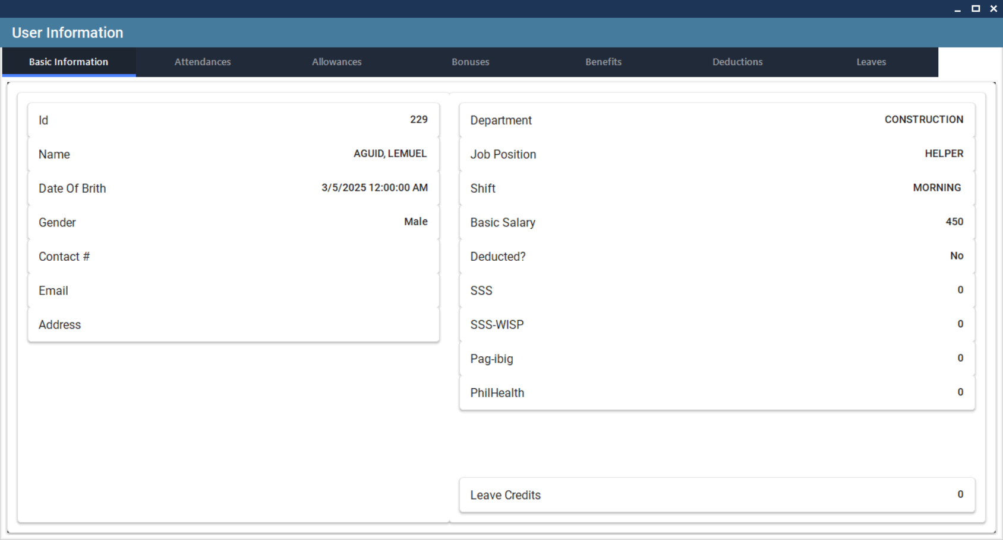

1. **Job Position Management**

This module allows businesses to **define, track, and manage employee job roles**, ensuring clear organizational structure and accurate payroll processing.

* + *Creating Job Position*: Click on Add New, enter details and finalize. This will open a new form.
    1. Enter Job Position Information
       - Title (Required: Unique identifier for the Job Position)
       - Description (Optional: Additional details about the Job Position)
    2. Save the Job Position
       - Click Save to store the new Job Position in the system.
    3. Printing or Further Processing
       - If needed, click Print to generate a report of all Job Position.
  + *Editing Job Position*: Click from the list to select a Job Position, then click Edit to modify its details. *(Note: The process is the same as creating a Job Position.)*
  + *Deleting Job Position*: Click from the list to select a Job Position, then click Delete to remove it.
  + *Saving Job Position*: Click Save to confirm modifications.
  + *Generating Reports*: Click Print to generate a report of all Job Positions.

1. **Leave Management**

This module allows businesses to **track, manage, and process employee leave requests**, ensuring smooth workforce planning and payroll accuracy.

* + *Creating Leave*: Click on Add New, enter details and finalize. This will open a new form.
    1. Enter Leave Information
       - Select Employee
       - Start Date
       - End Date
       - Leave Type
       - If Other (Optional: if the selected leave type is other)
       - Status
       - Note
    2. Save the Leave
       - Click Save to store the new Leave in the system.
    3. Printing or Further Processing
       - If needed, click Print to generate a report of all Leave.
  + *Editing Leave*: Click from the list to select a Leave, then click Edit to modify its details. *(Note: The process is the same as creating a Leave.)*
  + *Deleting Leave*: Click from the list to select a Leave, then click Delete to remove it.
  + *Saving Leave*: Click Save to confirm modifications.
  + *Generating Reports*: Click Print to generate a report of all Leaves.

1. **Project Management**

This module allows businesses to **track, manage, and allocate resources to projects**, ensuring proper budgeting, cost tracking, and efficient task management.

* + *Creating Project*: Click on Add New, enter details and finalize. This will open a new form.
    1. Enter Project Information (Limited due to payroll functionalities, you must contact the administrator or anyone from the Inventory team to add other information.)
       - Name (Required: Unique identifier for the Project)
       - Description (Optional: Additional details about the Project)
    2. Save the Project
       - Click Save to store the new Project in the system.
    3. Printing or Further Processing
       - If needed, click Print to generate a report of all Project.
  + *Editing Project*: Click from the list to select a Project, then click Edit to modify its details. *(Note: The process is the same as creating a Project.)*
  + *Deleting Project*: Click from the list to select a Project, then click Delete to remove it.
  + *Saving Project*: Click Save to confirm modifications.
  + *Generating Reports*: Click Print to generate a report of all Projects.

1. **Shift Management**

This module allows businesses to **schedule, track, and manage employee work shifts**, ensuring accurate attendance tracking and payroll processing.

* + *Creating Shift*: Click on Add New, enter details and finalize. This will open a new form.
    1. Enter Shift Information
       - Name (Required: Unique identifier for the Shift)
       - Start Time
       - End Time
       - Regular Hours (Based on start time and end time)
    2. Save the Shift
       - Click Save to store the new Shift in the system.
    3. Printing or Further Processing
       - If needed, click Print to generate a report of all Shift.
  + *Editing Shift*: Click from the list to select a Shift, then click Edit to modify its details. *(Note: The process is the same as creating a Shift.)*
  + *Deleting Shift*: Click from the list to select a Shift, then click Delete to remove it.
  + *Saving Shift*: Click Save to confirm modifications.
  + *Generating Reports*: Click Print to generate a report of all Shifts.

1. **Tax Management**

This module allows businesses to **define, calculate, and apply taxes to employee salaries and product transactions**, ensuring compliance with tax regulations and accurate payroll processing.

* + *Creating Tax*: Click on Add New, enter details and finalize. This will open a new form.
    1. Enter Tax Information
       - Minimum Salary
       - Maximum Salary
       - Tax Rate
    2. Save the Tax
       - Click Save to store the new Tax in the system.
    3. Printing or Further Processing
       - If needed, click Print to generate a report of all Tax.
  + *Editing Tax*: Click from the list to select a Tax, then click Edit to modify its details. *(Note: The process is the same as creating a Tax.)*
  + *Deleting Tax*: Click from the list to select a Tax, then click Delete to remove it.
  + *Saving Tax*: Click Save to confirm modifications.
  + *Generating Reports*: Click Print to generate a report of all Taxes.

1. **Payroll Management**
   * *Payroll Generation***:** Navigate to the **Payroll** section, where users can generate payroll reports for a specific pay period. Select the employee group, verify salary components, and finalize payroll.

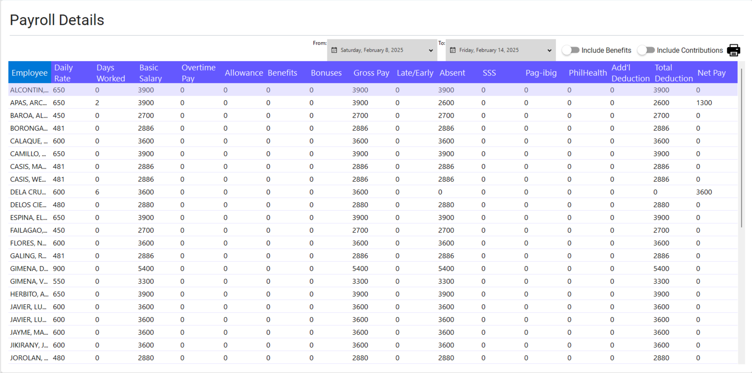The system allows generating payslips and exporting payroll data for further processing. Click the individual employee payroll generated on the list to generate a payslip.

